**Developing a Flight Delay Prediction Model using Machine Learning.**

**Data Flow Diagram & User Stories**

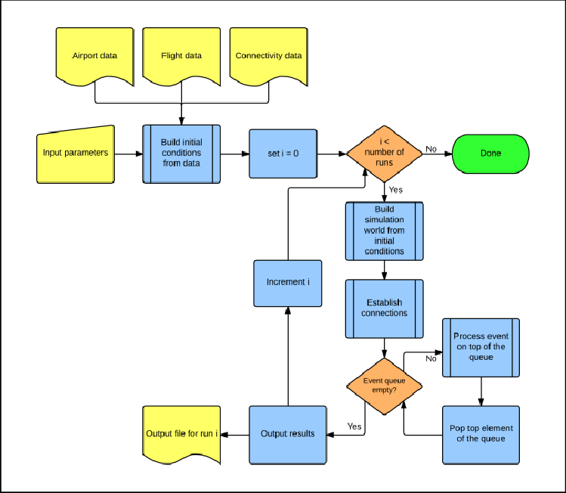

If one flight is delayed, but still able to depart and arrive within its currently assigned ATFM slots, delay needs to be propagated to the next leg in the aircraft’s rotation and the passenger/crew connections (if any).

If a flight is delayed (because of a primary or a reactionary delay) and lost its slots, the simulation tries to find a new suitable pair of slots (first through re-scheduling, then through slot swapping), which also may cause delay to be propagated. If these processes fail, the flight and all the successive legs in the same aircraft’s rotation are cancelled.

If a flight has no delay, no measure is necessary, i.e. the flight will depart and land as scheduled.